Libspace
Project title
Libspace API – A Robus t Backend for library operations
1. Project Overview
LibSpace is a web-based Library Management System developed to simplify and digitalize library operations. It provides secure user authentication and efficient book management features. The system allows users to register, log in, and manage their accounts safely.
After successful authentication, users can perform CRUD (Create, Read, Update, Delete) operations on books. This includes adding new books, viewing available books, retrieving book details by ID, updating book information, and deleting books from the system.
The primary objective of LibSpace is to demonstrate a well-structured backend system that integrates authentication mechanisms, RESTful API design, and database management. The project focuses on implementing secure user access, organized data handling, and efficient backend functionality in a scalable manner.
2. Project Instructions – LibSpace
Follow the steps below to use the LibSpace application effectively:
Create a new account by registering through the user registration form.
Log in using your registered email/username and password to access the system dashboard.
Once logged in successfully, you can manage books using the following operations:
Add a new book to the library database.
View the complete list of available books.
Search and retrieve book details using Book ID.
Edit or update existing book information.
Remove a book from the system if required.
Log out securely after completing your tasks to ensure account safety.
Users also have the option to permanently delete their account from the system if needed

3.Project Architecture.
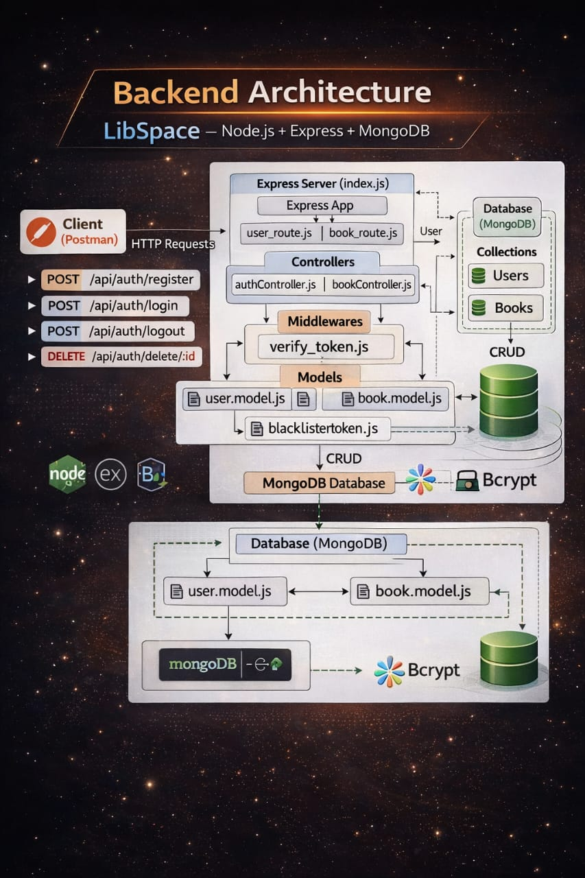
Technical Architecture
The LibSpace backend follows a layered architecture, which includes the following layers:
- API Layer (Routes)
- Controller Layer (Business Logic)
- Data Layer (Models / Database)
This layered structure helps maintain clean code, better organization, and easy development.
1. API Layer (Routes)
The API layer is responsible for receiving client requests and defining the application routes.
Technology Used:
- Node.js
- Express.js
Responsibilities:
Creating API routes such as /register, /login, and /books
Connecting routes with controllers
Handling HTTP request methods like GET, POST, PUT, DELETE
Applying middleware for authentication and validation
Example API Endpoints:
- POST – Register a new user
- POST – User login
- DELETE – Remove a user account
- POST – Add a new book
- GET – Retrieve all books
- PUT – Update book details
- DELETE – Delete a book
2. Controller Layer (Business Logic)
The controller layer contains the main logic of the application.
It processes the request received from the routes and performs the required operations.
Responsibilities:
Handling user authentication
Managing book-related operations
Processing client requests
Sending responses back to the client
Example controllers include:
authController.js
bookController.js
3. Data Access Layer (Models / Database)
The Data Access Layer is responsible for managing and storing the application data in the database. It defines the data structure using models and handles communication with the database.
Database Used: MongoDB
Models define the schema for:
- Users (name, email, password)
- Books (title, author, published_date, etc.)
Responsibilities:
Running database queries
Saving and retrieving data from the database
Ensuring data consistency and integrity
This layer connects the controllers with the database and manages all data operations.
4. Request Flow
- The client sends an HTTP request to the API endpoint.
- The route receives the request and forwards it to the appropriate controller.
- The controller handles the request and executes the required
- business logic.
- The controller communicates with the database through models.
- The database processes the query and returns the result.
- The controller sends the JSON response back to the client.
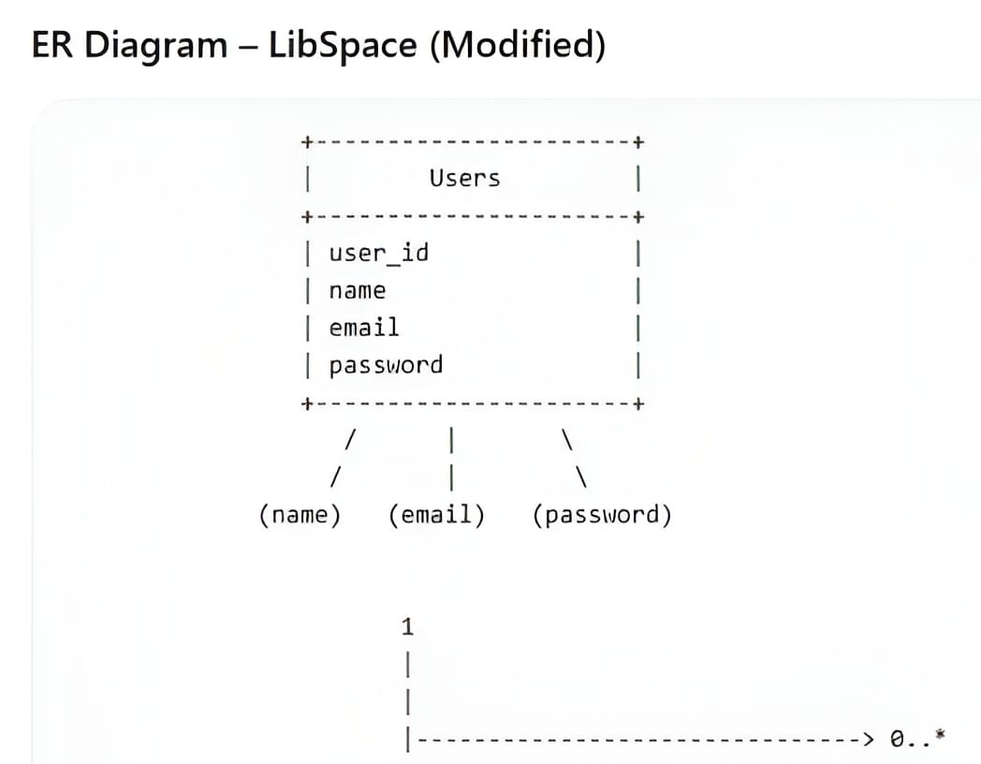
Features
- 1. User Authentication
- User registration with details such as name, email, and password
- Passwords are securely stored using hashing
- User login with credential verification
- JWT-based authentication for secure access
- Option to delete user account
- Automatic timestamps for record creation and updates (createdAt, updatedAt)
2. Book Management (CRUD Operations)
Each book is associated with a specific user using a reference (user ObjectId).
- Add a new book (title, author, published_year)
- Retrieve all books belonging to a user
- Fetch a single book using its ID
- Modify or update book information
Remove a book from the system
Book data can be accessed only by authenticated users
3. User–Book Relationship
One-to-Many Relationship
A single user can manage multiple books
Each book is linked to one user through an ObjectId reference
Maintains proper data consistency using MongoDB references
4. Security and Validation
Validation of input fields before processing requests
Protected routes using authentication middleware
Proper error handling for invalid requests
Prevention of unauthorized access
- RESTful API Structure
- Designed according to REST API standards
- Uses standard HTTP methods:
- POST
- GET
- PUT
- DELETE
API responses are returned in structured JSON format
Roles and Responsibilities
Requirement Analysis
Studying and understanding the project requirements such as authentication and book CRUD operations.
Planning and designing the database structure for Users and Books.
Identifying the relationship between User and Book entities (One-to-Many).
Database Design
Developing Mongoose schemas for storing data:
User Schema (name, email, password, timestamps)
Book Schema (title, author, published_year, user reference)
Creating ObjectId references to link books with users.
Maintaining data accuracy and consistency in the database.
API Development
Building RESTful API endpoints for backend functionality.
Implementing the following operations:
User Registration
User Login
Remove User Account
Add New Book
Retrieve Books
Edit Book Details
Delete Book
Organizing routes and controllers for better code structure.
Authentication and Security
Applying bcrypt for secure password hashing.
Generating JWT tokens for user authentication.
Securing private API routes using authentication middleware.
Managing unauthorized access and validation errors.
Error Handling and Validation
Checking required input fields before processing requests.
Handling incorrect login credentials.
Managing database-related errors.
Returning well-structured JSON responses.
Testing and Debugging
Testing API endpoints using Postman.
Confirming correct CRUD functionality.
Debugging issues and ensuring proper HTTP response status codes.
User Flow – Backend System
The user flow explains how the backend server processes requests and communicates with the database using APIs.
1.User Registration (Backend Process)
The client sends a POST request to the registration API endpoint /api/auth/register.
The backend server receives the request and validates the user input such as name, email, and password.
The password is securely encrypted using a hashing method.
After validation, the user information is stored in the database.
The server sends a success response confirming that the user account has been created.
2.User Login (Backend Authentication)
The client sends a POST request to the login API endpoint /api/auth/login.
The backend verifies the user's email and password with the database records.
If the credentials are correct, the backend generates an authentication token (JWT).
This token is returned in the response to the client.
The token will be used for accessing protected backend APIs.
3.Authorization and Protected Routes
When the user requests protected resources, the request must include the token in the header:
Authorization: Bearer <token>
The backend middleware checks and verifies the token.
If the token is valid, the request is allowed to access the API.
If the token is invalid or expired, the backend denies access and returns an error response.
4. Book API Operations
After authentication, the backend allows users to interact with book-related APIs.
GET /api/books – Retrieve all books from the database.
POST /api/books – Add a new book to the database.
PUT /api/books/:id – Update book information.
DELETE /api/books/:id – Remove a book from the database.
All these operations are handled by backend controllers and connected to the database.
5. Logout
The logout functionality ensures that a user’s session becomes invalid and the authentication token can no longer be used.
The user sends a request to the endpoint:
/api/auth/logout
The authentication token is added to a token blacklist to prevent further usage.
After logout, the user session becomes invalid, and protected routes cannot be accessed.
6. Delete User Account (Optional Feature)
This feature allows users to permanently remove their account.
• The user sends a DELETE request along with their userId.
• The system deletes the user record from the database.
Overall System Flow
Process:
User Registration → User Login → Token Generation → Access Secured APIs → Perform CRUD Operations → Logout

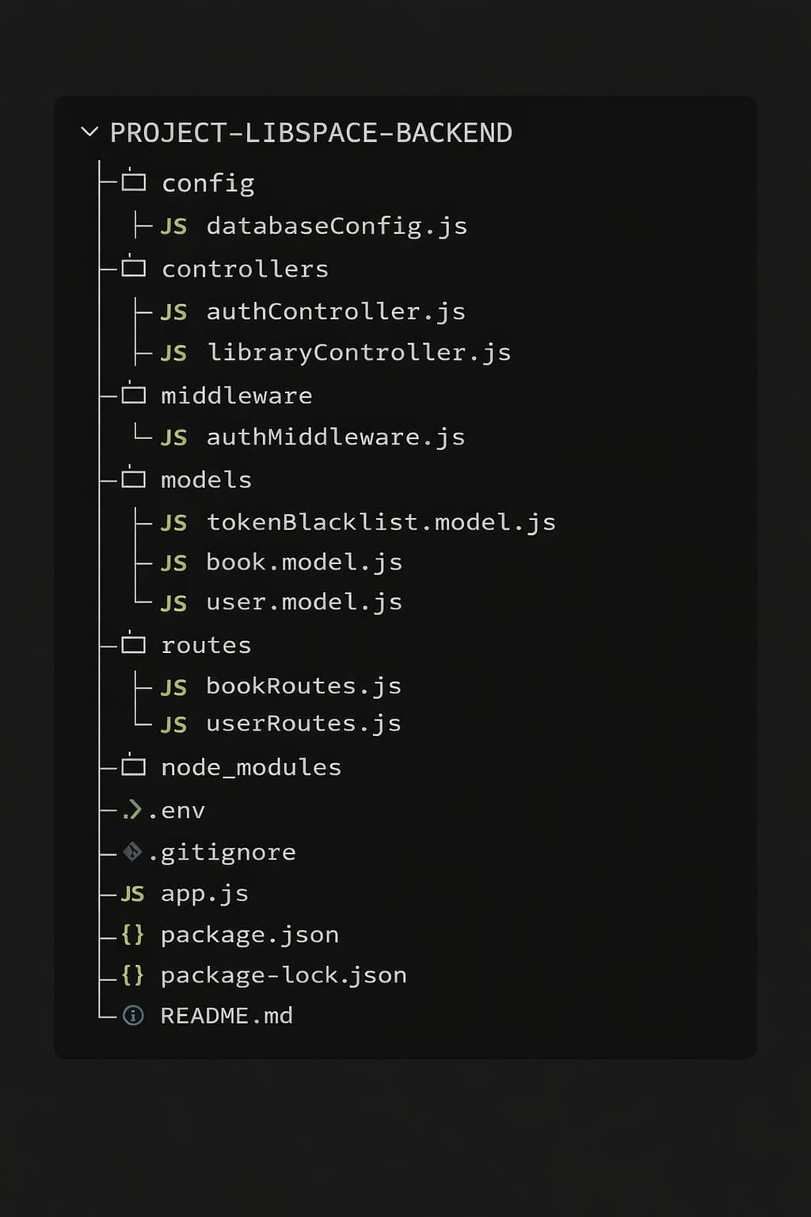
Authorization FormaProject Directory Structure.
Project Setup
1. Install Dependencies
First, install all required backend packages using npm:
Copy code

npm install
This command installs all the dependencies listed in the package.json file required for running the backend application.
2. Configure Environment Variables
Create a .env file in the root folder of the project and add the following configuration:
Copy code

PORT=5000
MONGO_URI=your_database_connection_string
JWT_SECRET=your_secret_key
Replace your_database_connection_string with your MongoDB database connection URL.
Replace your_secret_key with a secure random key used for authentication.
3. Start the Database
Ensure that MongoDB is installed and running on your system.
Also verify that the connection string in the .env file correctly connects to the database.
4. Run the Backend Server
Start the backend application using the following command:
npm start
If you are using nodemon for development:
npm run dev
This will start the backend server and the API will run on the configured port.
Demo video link :
https://drive.google.com/drive/folders/1ifmxrUNATygNUttdsM1pIlJFMlZ2oiRR

